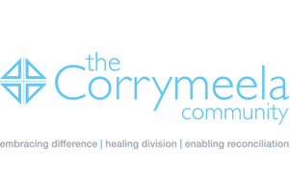

Corrymeela GB Conference November 2013 in London

Registration form for Confronting Terror and Violence: Stories of Conscience, Conviction and Courage from Northern Ireland
(based on the DVD UP Standing)

When - Saturday 16th November 2013
Where – St Ethelburga’s Centre, 78 Bishopsgate, London, EC2N 4AG
Time – from 10.00am (for 10.30am) until 4.30pm
Cost - £30 (to include lunch) with a reduced charge of £15 per head for unwaged, students

The conference will be facilitated by Susan McEwen (Development Director, Corrymeela and
David Price (Corrymeela Community Member)

This conference has been sponsored by St Ethelburga’s Centre

Booking information
To book your place, please complete the form below and return before the 6th November 2013

by post for the attention of Honor Alleyne and marked ‘Corrymeela Conference’ to 31 Tamarind Way, Earley, Reading, RG6 5GR, cheques should be made payable to the Corrymeela Community

or

by e-mail to honoralleyne@hotmail.co.uk (payment to be made on the day of the Conference)

Name/s: ___________________________________________________________________

Address (including postcode): ___________________________________________________________________________
___________________________________________________________________________
E-mail______________________________________________________________________

Tel. No.____________________________ Mobile (optional)_________________________

Any special dietary requests:____________________________________________________________________

I/we wish to reserve........ places(s*) at the November 2013 Corrymeela GB Conference to be held on Saturday 16 November at St Ethelburga’s Centre, 78 Bishopsgate, London, EC2N 4AG

*Please do not forget to include your cheque for £30.00*

